Assignment 4

Name:konyala sai vardhan reddy

Student id: **700745733**.

Github link: <https://github.com/vardhan141/ml4-assignment>

Recorded video link: https://drive.google.com/file/d/11i5H_ZABmR1Ud5RA0MRG5MIfAWWtohrX/view?usp=sharing

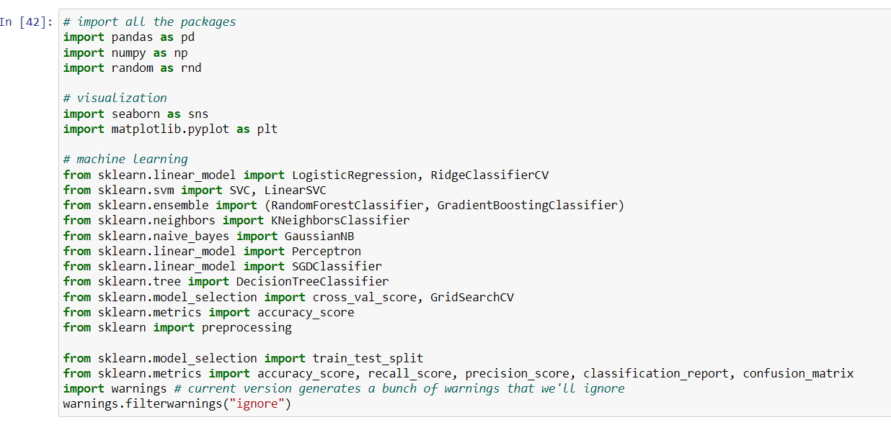first we import all the packages

we read file using pandas

using describe to get the description

Here we should keep the features as correlation is not that high

Plotting correlation

and spreadchart

